Algebra 1: Unit 5, Lesson 7

- Two equations in a system of equations that form intersecting lines will have one solution and will have __________________ slopes.
different

- Identify the solution(s) to the system of equations in the graph.
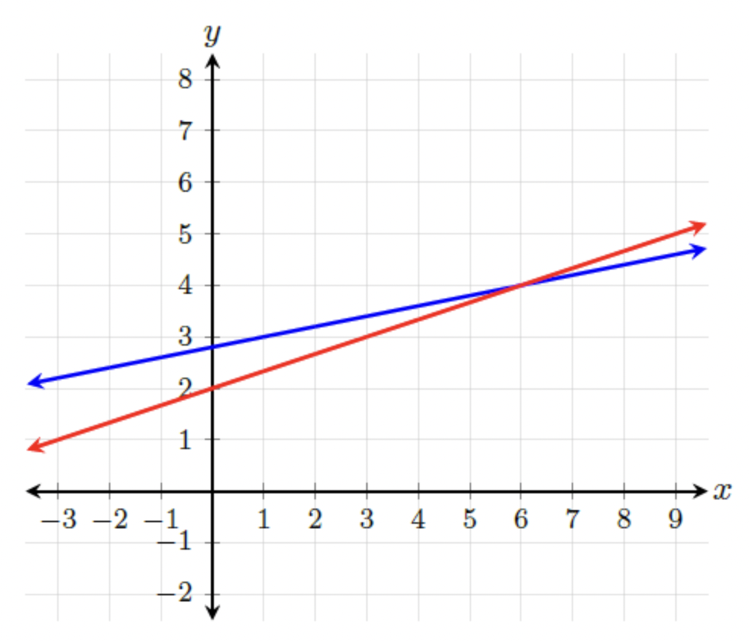
$$(6,4)$$

- The graph of a system of two linear equations is shown.
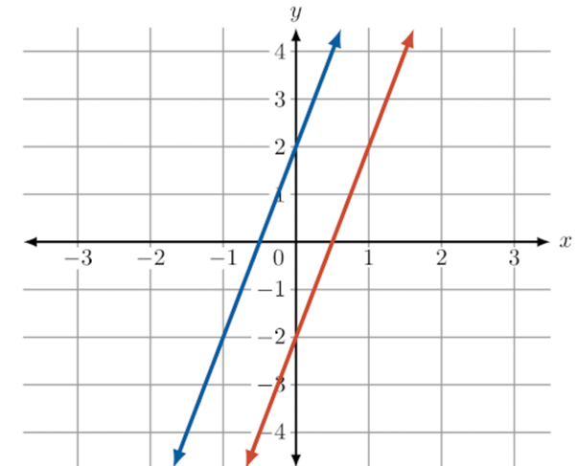
How many solutions does this system of equations have?
No solution

